Kindly fill in the following sections and submit the completed form to NTUitive via email gap_fund@ntu.edu.sg

Project Title: | CatchWise: Edge-AI Event & Anomaly Capture for Monitoring Systems
Name of Lead PI: | Fu Yuguang
School/Institute: | School of Civil and Environmental Engineering
Email: | yuguang.fu@ntu.edu.sg
Contact number: | +65 67905298
Name of Co-PI (if any) | None
Other Team Members (if any) | Li Jianfeng, Cui Shuaiwen

Kindly check where applicable

- Is this proposal covered by any existing IP? ☑ Yes ☐ No
If NTU IP, please state:
Adaptive Triggering Mechanism for Time-Series Data Sensing on Edge Devices, Singapore provisional patent application no. 10202502426R, 2025. [TD Ref: 2025-249-01-SG PRV]
*If a Technology Disclosure (TD) has previously been submitted to NTUitive on any invention related to this Gap Fund project. If a new Technology Disclosure will be submitted to NTUitive, please write in the above: New TD under Submission.
If non-NTU IP, kindly state: __________________________________
Kindly also elaborate for non-NTU IPs, whether the IP has been returned to you by NTU or whether it is your own IP.

- Has the research of this application been completed? ☐ Yes ☑ No
Has any proof-of-principle been obtained? ☑ Yes ☐ No
Has any paper on this technology been published? ☑ Yes ☐ No

- Have you previously applied for previous NTUitive Gap Fund calls?
☐ Yes ☑ No
If yes, was it successful in the previous grant call? ☐ Yes ☐ No
If no, at which stage was it rejected? Please complete Section 7.
☐ Preliminary ☐ Internal Review ☐ External Review

- Have you started any spin-off companies? ☐ Yes ☑ No
If yes, state the company name, UEN and date of incorporation: ____________________________________________________

- Are you interested in ☑ Licensing the technology ☑ Creating a spin-off ☐ To be decided later.

- Are you in discussion with any companies in the industry? ☐ Yes ☑ No
If yes, kindly state company names and comments:

- Has this project received any prior funding? ☑ Yes ☐ No
If yes, kindly state: MOE AcRF Tier 1, RG146/23

- Do you have research funding in place to further this technology (excluding potential POC grant)? ☐ Yes ☑ No
If yes, kindly state: _____________________________________

Project Details

1. Executive Summary

Please give a brief summary (no more than 500 words), with minimal technical terms, of the objectives and the scope of the project. The summary should also include the market need, proposed solution and comparison with competitors.

Market need. Monitoring systems in buildings, infrastructure, factories and homes are installed to catch brief events that may happen only once: a lift or chiller fault, an impact, a seismic response, a component failure, a fall. Collecting more data does not catch them. What catches them is deciding, at the moment it happens, that this is the event - then preserving the record that explains it and telling the responsible person in time to act.

Current gap. That decision is almost always a number fixed by hand: a threshold, a sampling schedule, an alarm rule, or a cut-off on an artificial-intelligence score. It is correct for the conditions in which it was set and for no others. As noise, load, occupancy, season or equipment condition change, the same number either floods operators with alerts or goes quiet - and quiet cannot be interpreted, because an event never detected leaves no record. A working system and a blind one look identical on the dashboard.

Proposed solution. CatchWise is an adaptive event-decision layer between sensing and action. The customer states the event class and the highest proportion of events they are willing to miss; CatchWise estimates how well the current decision is performing, moves the decision point as conditions change, and reduces false alerts only within that limit. One engine runs in two forms: on battery-powered endpoints it watches one or two low-cost indicators and wakes high-fidelity capture only when an event is confirmed; on controllers and gateways it governs the features, anomaly scores or classified outputs continuous monitoring already produces.

Project objectives and scope. The objective of this 18-month project - 15 months of execution plus three months of contingency - is to turn a laboratory-validated method into a product a monitoring or building-systems provider can buy and deploy. In scope: the decision engine, compact firmware, controller/gateway adapter, configuration tool, event-status interface and an algorithm-enabled reference module, validated on two event classes: one infrastructure event on constrained hardware through laboratory benchmark and field pilot, and one building mechanical-equipment anomaly through a partner gateway. Not in scope: dashboards, cloud platforms or diagnosis systems.

Commercial path and competitor comparison. The preferred route is licensing through NTUitive: software or firmware licensed per endpoint to building-management, Smart FM, industrial and equipment providers that already own the sensors, controllers and dashboards, with algorithm-enabled modules and pilot nodes where a ready embedded implementation is needed. Competitors sit on either side of this layer rather than inside it - sensor nodes, event recorders and edge-AI kits supply inputs; BMS and industrial platforms supply analytics and dashboards - and both leave the operating point fixed by hand. CatchWise keeps that point correct as conditions change and reports what it may be missing. The value is quantifiable: alerts that find no fault cost a building about S$28,800 a year in technician time, so halving that fraction without reducing detection is worth about S$360 per monitored asset per year, against an indicative licence of about S$20 per endpoint.

2. Value Proposition

2.1 Problem Statement

Briefly describe the problem to be solved and existing solutions in the market.
The problem. Infrastructure, industrial operations, smart buildings and home monitoring all face the same task: detect a short or emerging event, alert the right party, and keep enough data to act on. The difficulty is not sensing but deciding. The rule that separates an event from ordinary variation is commissioned once and then left, and it cannot check its own work: a false alert leaves a record that can be inspected, while a missed event leaves nothing at all. So when conditions drift, the operator cannot tell whether the system is safely quiet or silently blind - and when alerts become excessive the usual remedy is to raise the threshold, which converts a visible nuisance-alert problem into an invisible missed-event one.
Existing solutions, and what they leave unsolved. The market supplies four things well. Low-power chips and acquisition boards supply constrained sensing; monitoring nodes and event recorders supply deployable workflows; BMS and industrial platforms supply continuous collection, dashboards and alarms; and anomaly models - including mature offerings such as Siemens SIMATIC Anomaly Detection and ABB Ability Digital Powertrain - supply increasingly capable perception. None of them supplies the decision. Each delivers a signal, a feature or a score and leaves the customer to choose the point at which it becomes an event, an alert, a data capture or a work order; where a vendor model emits a classified event instead, that point has not been removed but fixed at training time, on the developer's data and against the developer's tolerance. CatchWise fills exactly that gap: it makes the customer's detection requirement explicit, estimates current decision quality on the device, and adapts the operating point locally.

2.2 Industry Analysis/Market Assessment

The team should perform an industry analysis/market assessment to identify current and future market trends. It should include the market segment (i.e. the targeted customers) and customer analysis.
Market segments and targeted customers. CatchWise serves connected monitoring systems in which a missed event or an excessive alert rate carries operational cost. The segments are entered in order of how hard they are to enter, not how large they are, so that evidence is earned where it is cheapest to earn and then spent where the value is greatest. (1) Entered first - infrastructure and construction monitoring. The easiest entry and the fastest proof: the events are short and costly to miss, the endpoints are resource-constrained, the team's published evidence, node platform and industry relationships are already in place, and monitoring-device manufacturers can be addressed directly through the module and firmware without passing a platform gatekeeper. (2) Entered second - building management and Smart FM. Lifts, chillers, pumps, fans, power and water systems are numerous and continuously monitored, but are reached through a small number of providers with long qualification cycles. Harder entry, and over the longer term the larger value pool, because one qualified integration carries across a whole portfolio. (3) Entered third - industrial condition monitoring. The technology transfers most directly of all, but incumbent suppliers hold decades of recorded fault data, so entry rests on the building-equipment result and on partner channels rather than on a new proof. (4) Transport and logistics remains a possible later product route. (5) Home and assisted-living monitoring is a longer-term adjacency whose obstacle is stated plainly: the event population there is behavioural rather than mechanical, so the modelled basis on which the missed-detection estimate rests would have to be established separately. Within this project the first two carry equal weight and different jobs - infrastructure supplies the technical credibility, building equipment the commercial credibility. The paying customers are BMS and Smart FM providers, equipment manufacturers, sensing suppliers and system integrators; owners, facilities teams, contractors and plant-maintenance teams are the operational users who validate the value.
Current market trends (TAM). Three parent markets bound the opportunity, and all three are growing faster than the labour available to serve them. Building automation systems: USD 101.7B in 2025 rising to USD 191.1B by 2030, a 13.4% CAGR, with Asia Pacific the largest region by 2030. Structural health monitoring: USD 2.78B in 2025 rising to USD 4.09B by 2029, a 10.4% CAGR, and 13.1% in Asia Pacific. Machine condition monitoring: USD 3.37B in 2025 rising to USD 4.70B by 2029, an 8.3% CAGR, 9.2% in Asia Pacific, with vibration monitoring the largest technique - which is the input CatchWise governs in both of its runtime profiles (MarketsandMarkets, 2025-2026 editions). These are cited as the ceiling on demand, not as CatchWise revenue, which is built bottom-up below. Table 1 sets out the three sizing levels and the entry sequence.
Future direction, and why it favours this project. The decisive number is the gap between two growth rates. Sensing and analytics capacity in buildings is compounding at 13.4% a year, while the Singapore facility-management market that must respond to what those systems report is growing at 2.41% a year, from USD 3.69B in 2025 to USD 4.26B by 2031, with hard services - the mechanical and electrical work an alert actually triggers - making up 53.6% of it (Mordor Intelligence, 2025). Detection capacity is therefore growing roughly five times faster than the capacity to act on it. Every one of those new detectors emits a score that needs a cut-off, and cheaper edge processors put continuous analysis on more devices, each of which then needs a decision policy; Singapore's Smart FM programme, which explicitly promotes fault detection, diagnosis and machine learning for anomaly identification, accelerates both sides. The market trend does not compete with CatchWise - it widens exactly the gap CatchWise closes, and it does so on detectors that providers have already paid for and installed.
Serviceable market: reachable channels (SAM). The serviceable market is counted in endpoints and in the people who must answer them, not as a share of the parent market. Singapore has more than 70,000 lifts and escalators (BCA) and about 1,300 registered lift and escalator technicians (MOM, 2021), half of whom are expected to retire within 10 to 15 years - an estimated 54 units per technician. At the base-case alert rates modelled in Section 2.4, every 1,000 instrumented lifts would generate about 14,400 technician-hours a year on alerts that find no fault, equivalent to roughly eight full-time technicians out of that national pool of 1,300 (estimate derived from the cited figures and the Section 2.4 model). Lifts alone therefore represent roughly 70,000 licensable endpoints in Singapore, an estimated S$1.4M a year of recurring licence value at the indicative S$20 per endpoint, before chillers, pumps, fans and air-handling units in the same buildings and before any module revenue. Construction and civil assets add the second reachable channel, with BCA projecting Singapore construction demand of S$47-53B for 2026 against S$50.5B in 2025 and S$39-46B a year over 2027-2030. The channel itself is highly concentrated: BCA's Contractors Registry lists only 6 firms at the top grade (L6) under workhead ME02, Building Automation, Industrial and Process Control Systems - Azbil, Siemens, Quantum Automation, Power Automation, Primustech and Conny Tech - with 14 more at L5, so roughly 20 firms hold the top two grades; and 63.0% of Singapore facility management is outsourced to specialist vendors. A small number of qualifications therefore reaches a large share of the installed base. Southeast Asia is the next reachable layer and China the later scale layer, both entered through equipment manufacturers and building-automation channels; the core algorithm stays common and only event definitions, interfaces and partners are localised.
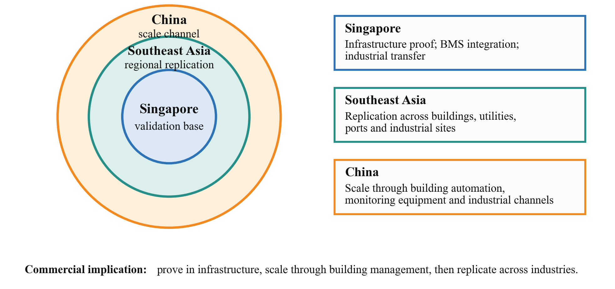
Fig. 1. Geographic Market Expansion Logic
Table 1. Market sizing levels and market entry sequence
Market-sizing level | Definition for CatchWise | Evidence / filters | Relevance to the application
TAM - Total Addressable Market | Global/regional monitoring markets where event or anomaly decisions affect safety, maintenance, downtime or service cost: building automation/Smart FM, infrastructure monitoring and industrial condition monitoring. | Building automation USD 101.7B (2025) to USD 191.1B (2030), 13.4% CAGR; structural health monitoring USD 2.78B (2025) to USD 4.09B (2029), 10.4% CAGR (13.1% in Asia Pacific); machine condition monitoring USD 3.37B (2025) to USD 4.70B (2029), 8.3% CAGR, vibration the largest technique (MarketsandMarkets). | Establishes the ceiling on demand and its growth rate; CatchWise revenue is tied to the narrower, reachable accounts below.
SAM - Serviceable Addressable Market | Reachable Singapore and Southeast Asian segments where partners already control connected endpoints, controllers, gateways or maintenance workflows. | Singapore beachhead: >70,000 lifts and escalators against about 1,300 registered lift/escalator technicians (BCA; MOM 2021); Singapore facility management USD 3.78B in 2026 growing at 2.41% CAGR, 53.6% hard services, 63.0% outsourced (Mordor Intelligence); BCA projects S$47-53B construction demand for 2026 against S$50.5B in 2025; BCA Contractors Registry workhead ME02 lists 6 firms at grade L6 and 14 at L5. | Defines the near-term customer set and its size: about 70,000 licensable lift/escalator endpoints in Singapore alone, an estimated S$1.4M a year of recurring licence value at S$20 per endpoint, before other building plant.
SOM - Serviceable Obtainable Market | Realistic 3-5 year beachhead captured through a small number of licence, module, integration and pilot-node accounts. | Built bottom-up from partner accounts: endpoint count, attach rate, annual licence price, module price, integration revenue, support revenue and adoption timing; cross-checked against the endpoint and firm counts above. | Licence-led beachhead = 2 of about 20 top-grade firms and about 6% of the lift/escalator endpoints; licence-led growth = 36% of that asset class, so it requires plant beyond lifts and regional expansion. All figures are estimates pending customer discovery.
Entry sequence (by ease of entry) | 1. Infrastructure and construction (direct to manufacturers, evidence in hand) -> 2. BMS / Smart FM licensing (gatekept by few providers, largest value pool) -> 3. Industrial replication (incumbent-heavy) -> later: transport/logistics products; home monitoring as a longer-term adjacency. | Ordered by difficulty of entry rather than market size, so that evidence is earned where it is cheapest and spent where value is greatest. | Keeps the 18-month project focused on the two markets that can actually be proved, while preserving multi-industry growth.

Obtainable market: the beachhead accounts (SOM). What is obtainable in three to five years is a countable number of named accounts. The ladder in Table 2 is built from unit counts and price points so that each row can be challenged input by input, and it is worth checking against the SAM figures above. The licence-led beachhead row - two providers at 2,000 endpoints each - is 4,000 of the roughly 70,000 lift and escalator endpoints in Singapore, about 6%, and two of the 14 qualified L6 firms. The licence-led growth row - five providers at 5,000 endpoints each - is 25,000 endpoints, about 36% of that asset class and about a third of those firms; it is therefore reachable only by including building mechanical plant beyond lifts and by extending into Southeast Asia, and is not presented as a Singapore-only outcome. The module-led rows scale with units shipped rather than with installed base and are bounded instead by manufacturer count. Endpoint volumes per provider, attach rates and willingness to pay remain to be validated through customer discovery and dated partner feedback.
Customer analysis: who buys, and on what they decide. The route to scale runs through organisations that can embed the function once and deploy it across many endpoints, which is why the provider rather than the end user is the purchaser. Providers decide on seven criteria: missed detections against their own requirement, false-alert rate, notification latency, event-data completeness, integration effort, deployment cost, and compatibility with the sensors, models and workflows they already ship. The two segments weight them differently - constrained-device buyers add service life and data load, because a site visit costs more than the device; resource-rich buyers add alert triage, time to intervention and technician dispatches, because their cost is labour. Owners, facilities teams and maintenance contractors are not purchasers but are essential validators, since they absorb the cost of a false alert, a missed event or a late response.
Commercial potential. An account qualifies when four conditions hold together: a connected endpoint or gateway, a defined event or anomaly, a material consequence from missing it or over-alerting, and a provider that controls the device or the integration path. Revenue from a qualified account is then estimated from endpoint count, licence or module price, integration revenue, support revenue and adoption timing. The two ladders below should be read differently rather than compared at face value: module revenue is larger at the headline but linear and capital-bearing, whereas licence revenue is smaller at the headline but recurring, near-zero in marginal cost and compounding with the partner's installed base.
Table 2. Bottom-up annual revenue scenarios by commercial route
Commercial route / stage | Calculation basis | Revenue components | Annual revenue
Module-led: validation | 1 manufacturer x 200 modules x S$120 + 1 integration project x S$20k | S$24k + S$20k | S$44k
Module-led: beachhead | 5 manufacturers x 500 modules x S$120 + 2 integration projects x S$20k | S$300k + S$40k | S$340k
Module-led: growth | 5 manufacturers x 2,000 modules x S$120 + 3 integration projects x S$20k | S$1.20M + S$60k | S$1.26M
Module-led: platform | 10 manufacturers x 3,000 modules x S$120 + 5 integration projects x S$20k | S$3.60M + S$100k | S$3.70M
Licence-led: validation | 1 provider x 500 endpoints x S$20/year + 1 integration project x S$20k | S$10k recurring + S$20k | S$30k
Licence-led: beachhead | 2 providers x 2,000 endpoints x S$20/year + 2 integration projects x S$20k | S$80k recurring + S$40k | S$120k
Licence-led: growth | 5 providers x 5,000 endpoints x S$20/year + 3 integration projects x S$20k | S$500k recurring + S$60k | S$560k
Licence-led: platform | 10 providers x 10,000 endpoints x S$20/year + 5 integration projects x S$20k | S$2.00M recurring + S$100k | S$2.10M

Validation focus. The Gap Fund project converts these assumptions into evidence. Infrastructure testing and field pilot work prove the module route; building-equipment gateway integration proves the software-licence route. Both use the same acceptance gates in the same order: the agreed missed-detection ceiling first, then false-alert reduction, latency, event-data completeness, integration effort and demonstrated customer value.

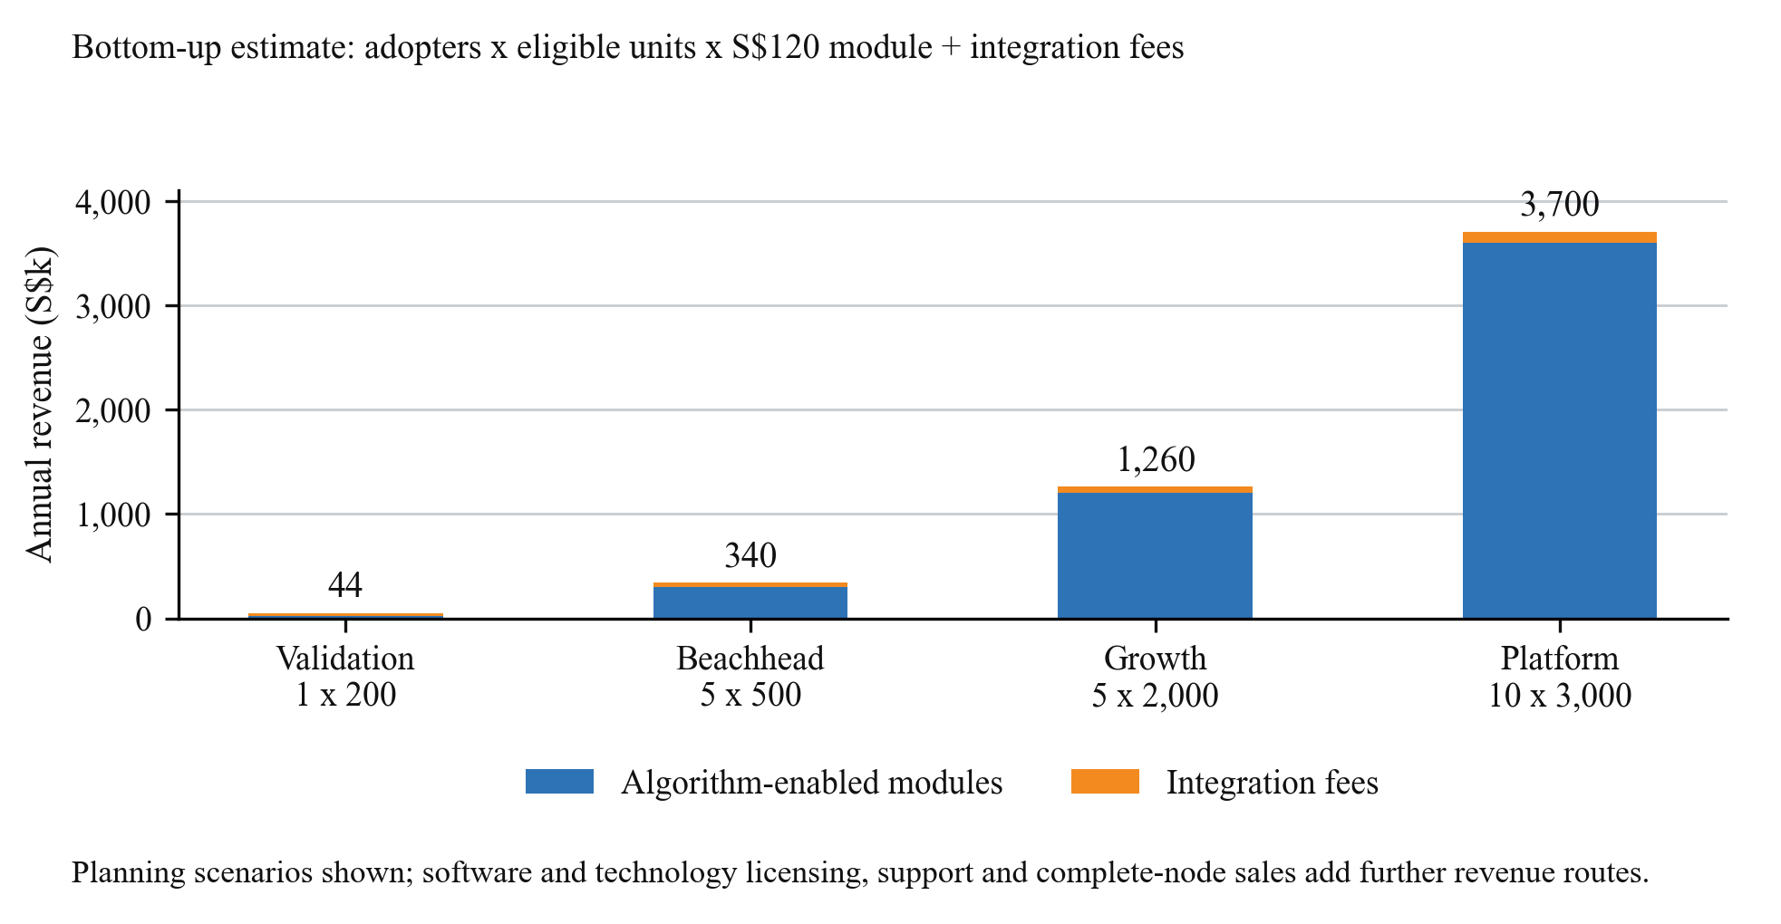
Fig. 2. Illustrative Module-led Annual Revenue Scenarios

2.3 Proposed Approach

Please describe how the proposed approach meets an unmet commercial or societal need.

The unmet need, commercial and societal. Commercially, providers do not need another dashboard; they need an event decision that is still trustworthy a year after commissioning, and a defensible answer when a building owner asks what the system might have missed. No product on the market gives them that answer, because no product measures it. Societally, the same gap decides whether a structural anomaly, a lift fault or a fall is acted on early or discovered late; and because unnecessary alerts consume the same technicians who respond to real ones, an unreliable decision degrades response to genuine events, not just to false ones.

How the proposed approach meets it. CatchWise makes the customer's tolerance the input rather than the outcome. The provider states the event class and the missed-detection ceiling; the engine estimates its own decision quality on the device, holds the ceiling as a constraint, and reduces false alerts only among settings that still satisfy it. Delivered as a productised engine with two runtime profiles - compact firmware that wakes high-fidelity capture on a low-power endpoint, and a controller/gateway adapter that governs engineered features, anomaly scores or classified outputs - both profiles expose the same configuration, sensitivity target, event-status output and associated-data reference. The commercial consequence is that this is one decision layer sold twice, not two unrelated devices, and that a provider can state a detection commitment they cannot state today.

Why it can actually be adopted. An unmet need is only met if the customer can take it up. CatchWise is added at the decision layer, so providers keep their sensors, models, dashboards and maintenance workflows; the adoption work is interface mapping and event-class definition, not replacement. The first commercial offer is therefore a software or firmware licence with paid integration, with algorithm-enabled modules and complete pilot nodes where a manufacturer or field user needs a ready embedded implementation - which also lets NTUitive and the team test willingness to pay on both routes during the project rather than after it.

2.4 Benefits and Costs

Please describe how the proposed technology impacts industry needs and the value creation in Singapore. It must include the value-add to customers that adopt the technology such as the manufacturability and scalability, production costs and consideration for the cost of adoption (e.g. change in production line, compatibility and ease of incorporation with existing processes).
Impact on industry needs in Singapore. Singapore's monitored assets are dense, heavily used and maintained by a workforce that cannot grow with them, which is precisely the condition in which decision quality, not sensing quantity, sets the outcome. The near-term needs are in construction and infrastructure, building services, advanced manufacturing, data centres, process plants, ports and logistics. The scale of the effect is documented: in a BCA-JTC trial across 174 lifts at CleanTech Park and one-north, conducted with KONE, Schindler and TUV SUD, remote monitoring and diagnostics achieved 85% accuracy in predicting lift faults and improved manpower productivity by 25%, with rollout to a further 180 lifts planned over the following two years (BCA/JTC media release, 29 July 2022). That is independent evidence that the binding constraint in this industry is technician time, which is the quantity a better decision layer acts on directly. Table 3 maps each Singapore segment to its sizing basis.
Local opportunity and channel depth. Building management is the primary Singapore scale-up channel because a small number of providers reach many buildings and endpoints through the controllers, gateways and maintenance workflows they already operate, so one qualified integration carries across a whole portfolio. Infrastructure and construction monitoring remain the first proof market because the team's technical evidence is strongest there and manufacturers can be addressed directly. Account-based customer discovery runs across the first two commercial steps of Section 2.6, Months 0 to 6, and will establish provider endpoint volumes, integration effort and preferred commercial terms, and test the indicative local opportunity estimates in Table 3.
Table 3. Singapore segments: scenarios, sizing basis and evidence to be generated
Singapore segment | Concrete scenarios / example targets | Market-sizing role | Evidence to be generated
Building management / Smart FM | Lift, chiller, pump, fan, power and water anomalies; Johnson Controls, Schneider Electric, Siemens, Honeywell, Azbil, Quantum Automation, ST Engineering Urban Solutions | Core SAM and first software-licence route. >70,000 lifts and escalators nationally, served by about 1,300 technicians; at base-case alert rates every 1,000 instrumented lifts would consume an estimated 14,400 technician-hours a year on alerts that find no fault, about 8 full-time technicians. Channel: 6 firms at BCA grade L6 and 14 at L5 under workhead ME02. | Customer discovery will quantify endpoint volumes, attach rate, licence terms, integration cost and willingness to pay.
Construction and civil assets | Construction impact/vibration; bridge and rail response; seismic or sudden structural events; Ackcio, SensingTech, Geomotion, Ryobi-G | First proof market and module / pilot-node route. BCA projects S$47-53B construction demand for 2026 (S$50.5B in 2025; S$39-46B a year over 2027-2030), sustaining a continuous population of instrumented sites. | Pilot work will establish pilot access, device volumes, module price and user acceptance.
Industrial monitoring | Factories, data centres, utilities and process plants; component, motor, pump, compressor and fan anomalies | Replication SAM after building-equipment validation. Machine condition monitoring is a USD 3.37B market growing at 8.3% (9.2% in Asia Pacific), with vibration monitoring the largest technique - the same input the engine governs. | Partner discovery will establish target accounts, data access and willingness to pay.
Transport and logistics | Ports, warehouses and high-value equipment movement; impact and shipment-shock recording | Later product route rather than a sized segment: the impact event is simple and damage is usually discovered on delivery, so a fixed threshold is more defensible here than elsewhere. | Future validation will establish use-case priority, annual device volume, channel partner and pricing.

Value-add to the adopting customer. The customer buys four common outcomes - fewer missed detections against their stated requirement, fewer false alerts, shorter detection latency and reliable notification - plus one thing no competing product offers: a reported estimate of what the system may currently be missing. Each profile adds its own operational gain. Constrained deployments gain wake-ups avoided, and therefore power, storage, communications and service life. Resource-rich deployments gain alert volume, technician review effort, time to intervention and avoided downtime. Because the size of that gain depends on each partner's assets, alert rates, investigation time and labour rates, it is presented in Table 4 as a parametric model rather than a fixed claim: a baseline is established from the partner's own maintenance records in Months 0 to 3, and re-measured in operation during the pilot in Months 9 to 12.
How the false-alert figure is built. The annual cost of alerts that found nothing is the product of the six named inputs in Table 4: monitored assets, alerts per asset per month, twelve, the fraction in which no fault is found, hours per investigated alert and loaded hourly cost. Every input can be replaced with a partner's own value, so the conclusion can be challenged term by term. In the base case the figure is about S$28,800 for one building; halving the no-fault-found fraction without reducing detection saves about S$14,400 per building per year, or about S$720,000 a year across a fifty-building portfolio. The model excludes the cost of the fault that was missed, so it is a lower bound on the benefit.
Table 4. Parametric false-alert cost model for one building
False-alert cost model input | Conservative | Base case | High
Monitored assets per building | 20 | 40 | 80
Alerts per asset per month | 1 | 2 | 3
Alerts in which no fault is found | 30% | 40% | 50%
Hours spent per investigated alert | 1.0 | 1.5 | 2.0
Loaded cost per technician hour | S$40 | S$50 | S$60
Annual cost of no-fault-found alerts, one building | S$2,880 | S$28,800 | S$172,800
Annual saving if no-fault-found fraction is halved | S$1,440 | S$14,400 | S$86,400
Manufacturability, scalability and production cost. The product is manufactured as software first: the licensed engine and adapter carry essentially zero marginal production cost, which is what lets the licence route scale across a provider's installed base without a matching cost line. Where hardware is required, manufacturability rests on a compact firmware profile that fits standard low-power microcontrollers, a reference module built from commodity sensors and components, and a bill-of-materials and design-for-manufacture review carried out inside this project so that a manufacturer can quote the module rather than re-engineer it. No new production line is needed on either side - the module uses conventional PCB processes, and the resource-rich profile ships as software onto controllers that already exist. Scalability is therefore limited by integration effort, not fabrication capacity, which is why integration hours are recorded as an acceptance indicator.
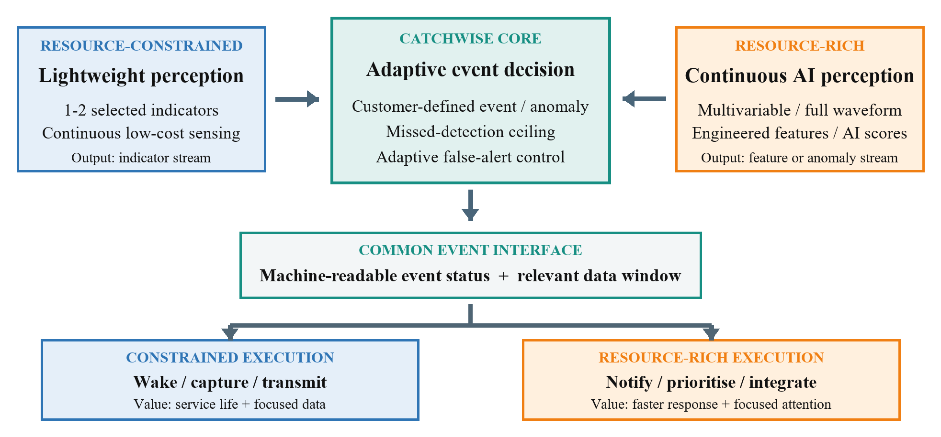
Fig. 3. CatchWise Dual-mode Value Architecture
Cost of adoption, compatibility and ease of incorporation. Adoption requires no change to a production line and no replacement of deployed equipment. CatchWise is inserted at the decision layer, so sensors, processors, radios, perception models, dashboards and maintenance processes stay as they are, and compatibility is handled by a defined detector-input, event-status and associated-data interface rather than by porting the customer's stack. The customer's actual work is interface mapping, event-class definition, benchmark testing and limited commissioning. Customers can enter at the smallest step that fits their architecture - a licence for an existing platform, a module for an OEM product, or a complete pilot node for field validation - and partner discovery during the project converts this into measured integration hours, incremental cost and support requirements.
Value creation in Singapore. Value is created at three levels. Operationally, safer and better-attended assets in buildings, infrastructure and plants, with maintenance effort directed at events that are real. Industrially, engineering and product-development activity in Singapore around embedded algorithms, low-power electronics and BMS integration, and a qualification route that local providers can use to differentiate their own products. Commercially, exportable intellectual property carried outward by Singapore-based automation, equipment and facilities-management partners: a local infrastructure proof followed by a building-equipment integration gives NTUitive and those partners evidence that transfers directly into industrial and regional markets.

2.5 Competitors

Please provide details of existing approaches/competitors in the same/similar market space in the following table. The team should also compare briefly the proposed technology/concept with that of the competitors’ (i.e. how the team’s technology is better, and what weaknesses there are). PI may wish to describe potential disruptive technologies.

The layer this project contests. Three functional layers surround this opportunity, and the project competes in only one. The sensing and acquisition layer supplies inputs: event-triggered devices, edge-AI kits, OEM acquisition boards, complete monitoring nodes. The platform and workflow layer supplies dashboards, fleet management and maintenance workflows. Between them sits the event-decision layer, where a signal, feature, anomaly score or classified output becomes an event that justifies an alert, an acquisition or a work order. CatchWise contests that middle layer only. Sensing devices are therefore inputs rather than rivals, and platforms are hosts and channels that become rivals only if they choose to build the decision layer themselves. Stating this narrowly is deliberate: it identifies both the defensible position and the partners named in Section 2.6.
Existing approaches at the decision layer. Adaptive thresholding is not itself novel, so the comparison is made between methods rather than between vendors. Whatever a detector emits, some rule with adjustable parameters sits between it and any action, and every practised alternative fixes those parameters somewhere: manually at commissioning; offline over recorded data at periodic recalibration; by hand on top of a continuous anomaly score; centrally from a cloud service; or at training time inside a classifier. Table 5 compares them on the four things that decide whether the decision stays correct in the field: how the operating point is set, what happens as conditions change, whether missed events are known at all, and what re-tuning costs.
Table 5. Existing approaches at the decision layer
Decision method | How the operating point is set | Under changing conditions | Knowledge of missed events | Cost of re-tuning
Fixed threshold or rule set | Set manually at commissioning | Unchanged; performance drifts | None; missed events leave no record | Site visit and re-commissioning
Offline exhaustive or periodic re-calibration | Searched offline over recorded data | Fixed between calibrations | Only at the calibration instant | Data upload and engineering time
Continuous anomaly scoring with a static decision threshold | Model supplies a score; threshold set by hand | Score distribution drifts while the threshold does not | Not quantified | Retraining or manual threshold revision
Cloud-side adaptive policy | Updated centrally from returned data | Adapts, subject to connectivity | Depends on outcomes reported back | Continuous connectivity and data egress
Detector that emits classified events | Confidence cut and class policy fixed at training time | Frozen; drifts as inputs move away from the training distribution | Not quantified | Retraining, or a policy change the customer often cannot make
CatchWise adaptive decision engine | Closed loop at the edge, subject to a customer-defined missed-detection ceiling | Operating point moves with the environment and operating regime | Estimated on-device from captured evidence and operating context | No site visit; no data egress required for tuning

How CatchWise is better: the secret sauce. The distinctive element is a sensitivity-first closed loop running at the edge, and it differs from every row of that table in three respects. The loop closes on the device, so the operating point moves with the environment instead of waiting for a site visit or a cloud round trip. The system maintains an estimate of its own missed-detection performance, not only a record of the alerts it raised - the one quantity every other approach leaves blank. And the requirement is set by the customer, not the supplier: the missed-detection ceiling constrains the search, and false alerts are reduced only among settings that still satisfy it. The result is a specification a purchaser can act on - detect the defined event class, report what may be missed, cut unnecessary alerts, hand over the data needed to act - and the same quantities serve as the benchmark metrics in Section 3.2 and the acceptance gates in Section 4.
Existing approaches by deployment profile. The two deployment profiles meet different incumbents, so they are compared separately in Table 6. On resource-constrained endpoints the alternatives are fixed-threshold recorders, duty-cycled nodes, OEM acquisition boards and edge-AI kits, all of which leave the event rule for the customer to tune; against these, CatchWise sustains event capture while cutting unnecessary wake-ups, storage and transmission, and supplies the productised decision policy and validation workflow they omit. On resource-rich controllers, gateways and platforms the alternatives are capable perception systems - including mature building and industrial anomaly analytics - whose decision policy is nevertheless static.
Table 6. Principal alternatives by deployment profile
Deployment profile | Principal alternatives | What they do well | What remains unsolved | CatchWise contribution
Resource-constrained endpoints  (low-power sentinel plus a high-fidelity channel woken on demand) | Event-triggered sensor devices and edge-AI development kits; OEM acquisition boards; fixed-threshold recorders and complete monitoring nodes | Low-power sensing, acquisition and ready-to-deploy devices with established supply chains | The customer still designs, tunes and validates the event decision; the setting is commissioned once and cannot be revised without a site visit; missed events are never observed | Supplies the decision layer and its self-assessment: a stated missed-detection ceiling, adaptive false-alert control, pre-trigger retention and measured resource cost
Resource-rich controllers, gateways and platforms  (high-fidelity and multivariable sensing running continuously; no sentinel) | Continuous anomaly detection and rule engines within building and industrial platforms, and third-party AI anomaly components (Honeywell, Siemens Industrial Edge, ABB and Schneider Electric are public examples) | Rich multivariable perception, dashboards, fleet workflows and enterprise integration | The step from an anomaly score to an actionable event remains a static, application-specific threshold; alert volume drifts across operating regimes and missed events are not quantified | Moves the decision point applied to those features or scores as conditions change, holds alert volume within a customer-set missed-detection ceiling, reports an estimate of what is being missed, and returns a consistent machine-readable event status

Why better perception does not close the gap. It is fair to ask why a sufficiently good model does not simply decide for itself. Two reasons. For events that are sudden, rare and consequential, labelled examples of failure are usually unavailable because the equipment has not yet failed in those ways, so what is deployed is unsupervised anomaly scoring - which by construction reports deviation from normal, not an event requiring action. And a supervised detector that names the event has not removed the decision; it has frozen it at training time, against the developer's tolerance rather than the operator's, and it drifts as the deployment moves away from that training distribution. The consequence is visible on every dashboard: an alert never raised leaves no record, so a working system and a blind one look identical, and when alerts become excessive the usual remedy is to raise the cut-off or switch the rule off - converting a visible false-alarm problem into an invisible missed-event one. Better perception raises what is achievable; it does not decide how much of that is realised at this site, in this season, for this customer. That is the step CatchWise supplies, on top of a vendor's model rather than in competition with it.
Weaknesses and risks. Five are material and are stated plainly. First, the layer cannot exceed what it is given: it cannot beat the sentinel's physical detection floor on a constrained endpoint, nor recover event information the supplied features or scores do not retain - so every event-and-perception pairing is screened for detectability before integration is committed. Second, the evidence base today is laboratory evidence for a single event class, with no field deployment, production volume or signed letter of intent (Section 2.8). Third, the resource-rich proof depends on partner access to equipment data and workflow, mitigated by falling back to partner-supplied data with a laboratory gateway. Fourth, a platform or equipment vendor could build adaptive decision control into its own stack; the response is speed to narrow verifiable evidence plus an implementation independent of detector and hardware, and therefore portable across vendors and both profiles. Fifth, where a vendor's model is already well calibrated, stable across regimes and exposes its decision parameters, the incremental value narrows to the missed-detection estimate and to consistency across a portfolio carrying several vendors' implicit operating points.
Potential disruptive technologies. Three developments could reshape this space: markedly better AI perception, much cheaper edge processing, and richer native analytics inside building and industrial platforms. None removes the need to set and maintain an operating point against a customer-specific tolerance; each multiplies the number of scores and detectors for which such a point must be set, which increases the value of a consistent decision layer. They may change where CatchWise is hosted - from a dedicated module into a provider's controller or gateway - which the dual-runtime design already anticipates. The genuinely disruptive scenario is not better sensing but a major platform vendor productising adaptive decision control itself, addressed as the fourth risk above.
Follow-on roadmap. Beyond the Gap Fund, the same labelled event libraries and digital-twin pipeline that characterise the estimators can also train class-specific detectors that report an event type directly, for the classes the team has productised. These would be offered as an optional, higher-performing perception input rather than as a replacement for a customer's own model, which preserves detector neutrality while allowing the team to supply both layers where it owns the data. This is a follow-on commercial route, not a deliverable of this project.
Relationship to the partners named in Section 2.6. Several platform providers appear here as potential internal builders of the decision layer and in Section 2.6 as priority channel partners; the two roles are consistent. What they lack at this layer is verified cross-mode evidence and a detector-neutral implementation tied to no single perception model or hardware family, so qualifying a validated layer is faster than building and proving an equivalent one - and it preserves their freedom to change perception models later.

2.6 Path to Commercialisation and Commercial Potential

Please provide details on the preferred “path to commercialisation”. It must include the expected product/service to be developed, mode of commercialisation (e.g. licensing the technology, or forming a start-up), how the team plans to get there (e.g. use of programmes & partners at NTUitive or industry contacts) and an estimated timeline for the commercialisation to take place. Describe key partnerships with clinicians, companies or other institutes that will enhance the commercialization potential of the proposed technology, and the risk factors to commercialisation (e.g. technical or market uncertainty). Highlight the aspects of this work that would attract investors or companies to develop the prototype or product from this Gap Fund work into a commercial entity.
Expected product and service. The product is the CatchWise adaptive event-decision engine, sold in three forms from one codebase: a software or firmware licence for controllers, gateways and existing device platforms; an algorithm-enabled module carrying the same engine for manufacturers and projects needing a ready embedded implementation; and a complete pilot node for field users who want a deployable system for validation. Around the product sit two services: paid interface adaptation and event-class configuration, and continuing support for connectors, updates and re-characterisation as a customer's fleet changes.
Mode of commercialisation. The preferred mode is technology licensing through NTUitive rather than immediate incorporation. This suits the asset, which is software with near-zero marginal cost, and the customer, who already owns the sensing and computing and needs the function embedded rather than supplied as a device. It also reaches the installed base fastest: a single provider licence propagates across a portfolio the provider already controls. A spin-off remains open as a later decision rather than a starting assumption, and the project is designed so that the choice can be made on evidence: if module demand and pilot-node pull prove stronger than licence uptake by the route-selection gate at Month 15, a company becomes the better vehicle, and NTUitive's venture-building support would be engaged at that point.
Who pays, and why. The paying customer is the provider, manufacturer or system integrator; the operational beneficiary is the building owner, facilities team, infrastructure owner or plant operator. Providers pay for three reasons of their own. Nuisance alerts are a cost inside their product - support calls, service visits, customer dissatisfaction - so reducing them without reducing detection improves their margin directly. A stated ceiling on missed events, backed by an on-device estimate, is a claim neither they nor their competitors can make today, and a differentiator in their own tenders. And a detector-neutral layer lets them change perception models later without renegotiating the decision logic. Pricing is anchored to measured value: in the base case of Section 2.4 the avoided cost is about S$360 per monitored asset per year against an indicative licence of about S$20 per endpoint per year - roughly one eighteenth of the quantified benefit, leaving room for the customer and for the price to rise with evidence.

Estimated commercialisation timeline. The commercial track runs in three-month steps alongside the technical milestones of Section 4, and follows the same 15-plus-3 structure: every committed commercial deliverable completes by Month 15, and the final three months are contingency. Each step is stated as an output that can be checked, not an activity that can be claimed.
Months 0-3, access and acceptance criteria. Build the target account list from the BCA Contractors Registry and the team's existing infrastructure contacts; open discussions with six to eight accounts; agree the two event classes and their acceptance KPIs with the two lead partners. The false-alert cost parameters of Section 2.4 are baselined from the building-side partner's own maintenance records in this window. Output: named target list, two agreed scope notes, baseline cost parameters.
Months 3-6, offer definition and price hypothesis. With NTUitive, define the three commercial forms - per-endpoint licence, algorithm-enabled module, pilot node - draft the licence structure, and set an initial price hypothesis anchored on the avoided cost measured above rather than on a margin target. NTUitive completes its intellectual-property review of the foreground assets in the same window. Output: draft term-sheet template, price hypothesis, IP position confirmed.
Months 6-9, first evidence to market. Take the constrained benchmark result to the monitoring-device manufacturers and the resource-rich benchmark to the building partner, and hold a structured willingness-to-pay conversation on measured numbers rather than on claims. Output: dated written feedback from at least two organisations, and the first paid-integration quotation issued.
Months 9-12, access converted into commitment. The field pilot and the gateway integration provide reference evidence, and the false-alert cost parameters are re-measured in operation against the Month 0-3 baseline, so the economic case rests on observed rather than reported values. Each engaged partner is then asked for the endorsement agreed with them in Section 2.8. Output: at least one dated letter of support or letter of intent, and validated cost parameters. First revenue is expected in this window, as paid integration or a pilot engagement.
Months 12-15, route selection and commercial close-out. Compare the two routes on what was actually observed - endpoint volumes offered, integration hours measured, prices accepted - and select the lead route with NTUitive. Complete the reference-customer material and open follow-on funding or joint-development discussions in the same window, so that nothing committed depends on the contingency period. Output: final commercial package (licence terms, module specification and price, integration scope), a documented route decision, the commercial dossier, and a named follow-on pipeline.
Months 15-18, contingency. No new commercial deliverable is scheduled in this window. It is held to absorb schedule risk carried forward from the pilot and integration phases, to repeat any test whose result was inconclusive, and to convert late partner interest into dated endorsements. If contingency is not needed, the window is used to advance the follow-on funding and joint-development discussions opened in the previous phase.
After project close. A first licence or module agreement, a joint-development project, or a start-up decision if module and pilot-node demand prove stronger than licence uptake - targeted within 6 to 12 months of project close and subject to partner validation.

Key partnerships and how the team gets there. Two partner tracks run in parallel. On the first market, infrastructure and construction users together with monitoring-device manufacturers define the constrained proof and host the field pilot; the team's existing relationships in this segment, described in Section 2.8, are the starting point. On the expansion market, building-automation, Smart FM and building-equipment providers define the resource-rich anomaly, the data interface and the workflow value, and are the route to portfolio scale. The channel is small enough to name: BCA's Contractors Registry lists Azbil, Siemens, Quantum Automation, Power Automation, Primustech and Conny Tech at the top grade under workhead ME02, and global building-automation vendors including Johnson Controls, Schneider Electric, Honeywell and ST Engineering Urban Solutions are active in the same segment. NTUitive is the mechanism for reaching them: introductions and industry engagement, licensing structure and term-sheet support, intellectual-property review of the foreground assets, and conversion of technical interest into KPI-linked letters of support or intent.

Risk factors to commercialisation. The technical uncertainties are event-class detectability, the validity of the perception inputs a partner supplies, convergence of the adaptation under drift, and the error of the missed-detection estimator; each is screened or measured early, in the first three months for detectability and in the benchmarks for the rest, and is reported rather than absorbed. The market uncertainties are partner access, integration effort, willingness to pay and the possibility that a vendor builds the layer internally; these are mitigated by running two independent partner tracks, by recording integration hours and false-alert cost as measured acceptance indicators rather than assumptions, and by keeping the interface hardware- and detector-independent so that no single partner decision can strand the technology.
What would attract a company or an investor. Four things. A defensible core asset that is software and improves with use, since the labelled event libraries and estimator characterisations built for each productised class cannot be assembled by waiting for rare failures. A clean intellectual-property position held by NTU with a defined licensing route through NTUitive, as set out in Section 3.1. Evidence obtained in the market where the team is strongest, then shown to transfer to the market that is largest - which is the specific question an acquirer or licensee asks. And a route into installed bases already numbered in the thousands of endpoints per provider, where adoption requires no change to the customer's hardware, models or production processes.

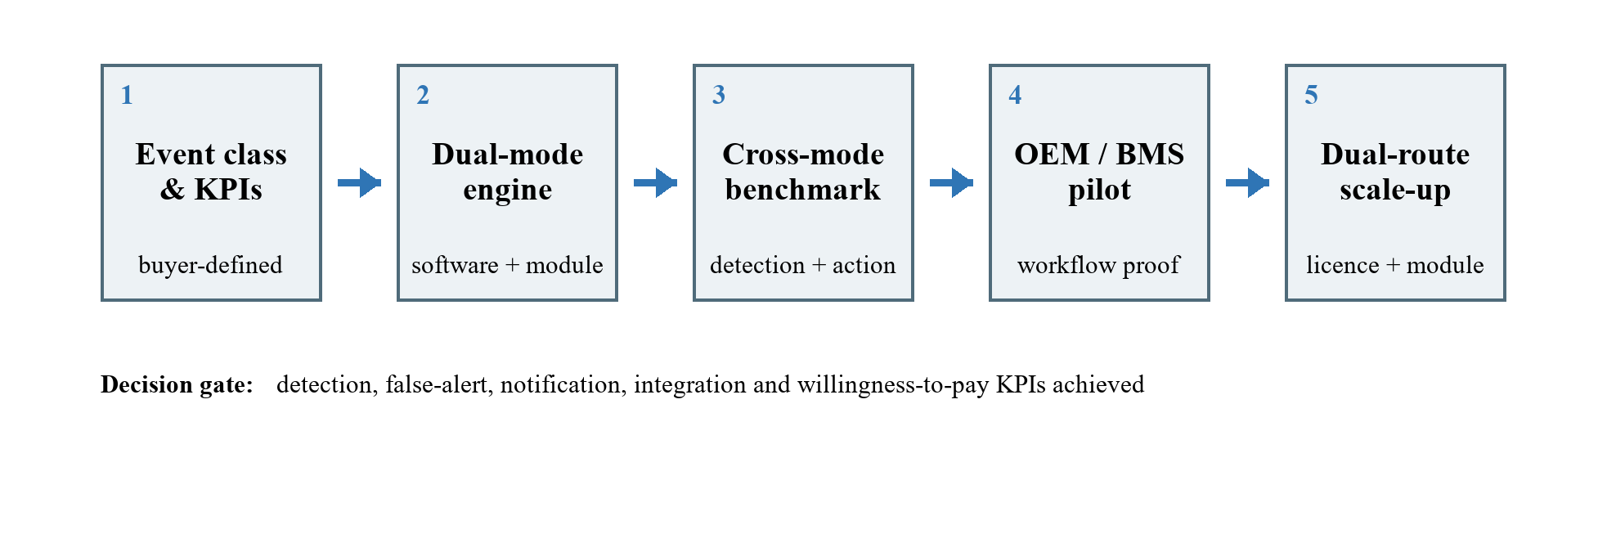
Fig. 4. Commercialisation and Scale-up Path

2.7 Team

Please provide a brief summary of the relevant expertise and qualifications of existing and future team members. Please also provide their basic contact details.
Existing team. The project is led by Dr. Fu Yuguang, Assistant Professor, School of Civil and Environmental Engineering, NTU (yuguang.fu@ntu.edu.sg, +65 67905298), whose research in IoT sensing, digital-twin modelling and structural health monitoring is the technical foundation of the method. Dr. Li Jianfeng and Mr. Cui Shuaiwen provide embedded implementation, experimental validation and benchmarking; Mr. Cui is the author of the published adaptive triggering method and of the embedded middleware on which the onboard layer runs, so the implementation know-how behind the background IP stays inside the team.
Future team members. Section 5 funds two appointments: a Research Fellow with embedded-systems and machine-learning experience to own the decision engine, the estimators and the two runtime profiles; and a Research Assistant to own test set-up, instrumentation and data analysis. External support for design-for-manufacture review, BMS interface integration and pilot coordination is engaged as needed rather than added as headcount.

2.8 Endorsements by Potential Investors or Customers

Please provide details of industry assessment in the potential outcome of the Gap Fund. Industry support letter or Letter of Intent (LOI) should be dated within three months of Gap Fund application. Any industry endorsement of the potential benefits, an industry benchmark of technical specifications, commercial value and marketability of the project outcome, or company incorporation as part of the pathway to commercialisation during the Gap Fund, or pre-secured customer orders, will be favourably viewed. If future funding support/customer orders is contingent on certain KPIs being met during Gap Fund, please make sure that these KPIs are included in this section.
Current status. No CatchWise-specific letter of intent or support letter is included with this application. What the team brings instead is documented prior access to both target markets through funded and proposal-stage work: an AI Singapore translational project with the Land Transport Authority; the coastal monitoring programme with Surbana Jurong and Terralab; and proposal-stage collaboration with Santarli Construction and R.A.K. Materials Consultants. These are prior project relationships, not CatchWise commitments. Any letter obtained during the project will be dated within three months of the submission it supports. Confirmation required before submission that each organisation may be named.

KPIs any endorsement will be tied to. Seven measured quantities: the agreed missed-detection ceiling for the defined event class; false-alert reduction against the relevant baseline; detection and notification latency; event-data completeness; integration effort; incremental adoption cost; and confirmation that the event status supported a real user action. Constrained validation adds wake-ups, power, storage and communications; resource-rich validation adds input compatibility, alert volume and workflow fit. Table 7 states which endorsement each partner type is asked for.
Table 7. Endorsement targets, assessments and expected evidence
Endorsement target | Relevant assessment | Expected evidence
BMS / Smart FM provider or equipment manufacturer | Resource-rich building-equipment event; multivariable/AI input; event-status interface; alert usefulness; endpoint volume, licensing and module pathways | Dated feedback, support letter, LOI, joint-development discussion or paid-pilot interest tied to KPI achievement. Target partner to be identified in Months 0-3.
Infrastructure field user, building owner or facilities team | Constrained infrastructure event; missed events; false alerts; wake/capture timing; resource benefit and workflow fit | Pilot feedback, benchmark acceptance, conditional willingness-to-pay statement or field-test access. Target organisation and naming permission to be confirmed.
Investor / commercial partner | BMS portfolio scale, infrastructure proof, industrial AI reuse and defensible decision-engine revenue | Follow-on discussion contingent on pilot KPI results. Investor or commercial-partner status to be confirmed.

Planned assessment. Two partners are engaged, one per profile: an infrastructure user or monitoring-device manufacturer for constrained detect-wake-capture validation, and a building-equipment, systems-integration or Smart FM partner for resource-rich gateway validation. The second partner also sets the false-alert cost parameters of Section 2.4, so the economic case is measured with the customer. Each is asked at the outset which endorsement its assessment could lead to, so the ask is agreed before the evidence is produced.

3. Technology

3.1 Background Intellectual Property (IP) / Underlying Technology

Table 8. Background intellectual property and underlying technology
Description | Type of IP | Owner (if applicable)
Smart adaptive triggering mechanism for event-driven time-series sensing on resource-constrained edge devices, covering the co-designed hardware and software architecture (low-power sentinel channel, event-driven power and signal switching, preservation and in-node alignment of pre-trigger information) and the closed-loop optimisation of triggering conditions. The invention was made at NTU, disclosed to NTUitive, and documented in Singapore provisional patent application No. 10202502426R, filed 26 August 2025. Inventors: Fu Yuguang, Cui Shuaiwen, Yu Xiao, Yu Xuewen. | NTU-owned invention and implementation know-how. A technology disclosure was submitted to NTUitive and a Singapore provisional application was filed in 2025; that provisional was not taken forward to a subsequent filing and the disclosure is currently being refined, so the technology is held by NTU as an unpatented invention and as implementation know-how, supported by the disclosure and the team's published validation. | Nanyang Technological University (NTU)
Low-power wireless sensing node platform used as the development and validation vehicle for the mechanism, implementing the dual-channel sensing architecture. The prototype has completed circuit design, board fabrication and production-level testing. | Previous work done by team members (NTU). Unpatented hardware design and know-how. | Nanyang Technological University (NTU)
Embedded computing middleware for resource-constrained microcontrollers, providing the digital signal processing and lightweight neural-network inference on which the onboard adaptive layer is implemented. | Previous work done by team members (NTU). Unpatented software. | Nanyang Technological University (NTU)
Implementation know-how for the adaptive capture workflow: firmware architecture for the sentinel and acquisition paths, onboard estimation and parameter-tuning implementation under microcontroller constraints, and the set-up of the pre-deployment optimisation environment. These implementation details form proprietary project know-how beyond the published methodology. | Previous work done by team members (NTU). Unpatented know-how. | Nanyang Technological University (NTU)
Experimental validation of the adaptive triggering mechanism on a laboratory structural testbed, reported in Mechanical Systems and Signal Processing 241 (2025) 113537 and in the Proceedings of SHMII-13 (2025), pp. 609-616. | Published academic work by team members. In the public domain and used here as supporting evidence. | Authors and publishers

Intellectual property position. All background technology in Table 8 was developed at NTU and is owned by NTU; external academic exchange was limited to general consultation on sensing-node design and created no third-party rights. A technology disclosure was submitted to NTUitive and a Singapore provisional application filed in 2025; that provisional was not taken forward and the disclosure is being refined, so the technology is currently held as an unpatented invention supported by implementation know-how and peer-reviewed publication. Filing status and preferred wording to be confirmed with NTUitive before submission. The foreground assets this project creates - the decision-engine implementation, configuration workflow, controller/gateway adapter, event-status interface, reference module design, labelled benchmark datasets and estimator characterisation - are new, and NTUitive will assess them for protection as they are created. Together they are what a licence conveys.
3.2 Detailed Technical Description (Maximum 6 pages)

Please describe the technical merits and application of this project in detail. A brief description of the methodology of how the proof-of-concept will be carried out experimentally, the expected outcomes and deliverables of the project (e.g. prototype, device, feasibility studies, animal/clinical trials, application platform, etc) should be provided.

3.2.1 Technical proposition, merit and scope
Technical proposition and merit. CatchWise turns a customer's event requirement into an adaptive decision rule, separating perception from decision: whatever the detector emits - a lightweight indicator, an engineered feature, an anomaly score or a classified output - CatchWise applies the missed-detection ceiling, moves the operating point as conditions change, controls false alerts and triggers the appropriate wake, capture, notification or prioritisation. The technical merit is that this layer closes a feedback loop on a quantity nobody else measures, its own missed-detection performance, and does so on the device under a limit the customer sets.
Design principles. Four principles govern the design. Sensitivity before optimisation: the agreed missed-detection requirement is a constraint, not one term in a weighted score. Asymmetric decision control: missed events carry the dominant penalty. Resource-aware perception: each deployment uses the simplest sensing path that can represent the event. Action-ready edge intelligence: the decision and the first machine-readable event status are produced next to the data.
Scope boundaries. The project builds the decision engine, the firmware and adapter profiles, the event interface, the reference module and the validation package. It does not build a BMS, a cloud dashboard or a diagnosis system; host platforms continue to provide notification routing, dashboards and final diagnosis. Home fall detection is excluded for a specific reason: its event population is behavioural rather than mechanical, so the modelled basis for the missed-detection estimate would have to be established separately.
3.2.2 What is measured, and why
The quantities that matter. Both profiles report missed detections, false alerts, detection latency, notification delivery and event-data completeness, with detectability characterised against noise and operating state; the constrained profile adds wake-up delay, power, storage and communications, the resource-rich profile adds alert volume, stability across regimes and review effort saved. Because site conditions change throughout deployment, an adaptive operating point - rather than repeated site tuning - is what holds these quantities where the customer set them.
3.2.3 The adaptive decision loop
The invariant problem. Three difficulties make a detection decision hard to set and to keep correct. There is no analytical relation between the decision parameters and the performance they will produce at a site. The decision cannot observe its own errors: a false alert leaves a record, a missed event leaves nothing. And every field evaluation consumes real elapsed monitoring time. Only the third is created by a constrained power budget. The published method was developed on battery-powered nodes because that is where the problem is most urgent, but the difficulty it addresses is the second, which belongs to event-triggered and alert-based operation rather than to the energy budget. Energy scarcity made the problem urgent; unobservability made it hard; and it is the hard part that survives when the energy constraint disappears.
Every detector has decision parameters. Between perception and action there is always a rule with adjustable parameters: on a constrained node, an amplitude threshold and a persistence count; on a controller, a threshold on a score, a confirmation window, a hysteresis band, a minimum inter-event interval and, for a classifier, a confidence cut per class. A detector that outputs a label has not removed these parameters - it has fixed them at training time, on the developer's data and against the developer's tolerance for a missed event, which is not the operator's and is not revisited when the site changes. CatchWise treats this parameter set as the quantity to be governed, which is what makes the engine independent of the perception in front of it: the same product sits behind a raw vibration channel, an engineered feature, an anomaly score or a classifier.
The closed loop. Fig. 5 shows the engine. Four parts, each with a fixed role: the environment supplies the signal and the operating context; the system is the decision rule and its parameters; the estimator judges how that rule is currently performing; the controller changes the parameters within bounds validated before deployment. The loop runs where the data are and runs continuously, so the decision is re-derived as the site changes instead of being inherited from the day it was commissioned.
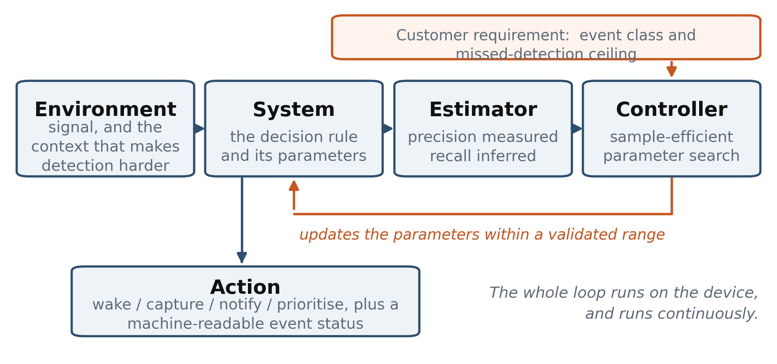
Fig. 5. The adaptive decision loop: four roles, closed on the device
3.2.4 Estimating performance and moving the operating point
Precision is measured; recall is inferred. The estimator consists of two learned functions that differ in kind, shown in Fig. 6. The first labels what was actually captured, which gives the false-alert side directly: recorded material judged not to be of interest is, by definition, a false alert. The second regresses achievable detection performance from the current decision parameters and the observed operating context, which gives the missed-event side by inference, because there is nothing there to observe. Both are small enough to run beside a customer's own firmware on a microcontroller. The inference is legitimate because achievable recall is a function of three things - the decision parameters, the operating context and the population of events that could occur - and two of the three are known at run time.
Where the third term comes from. Not from the field, because the field is exactly where the truth is unavailable. It is established offline, where the truth is known by construction: a digital twin generates event and background sequences whose contents are known exactly, so for any combination of decision parameters and context the achievable performance can be computed rather than assumed. Sweeping those combinations produces the labelled material the estimator is trained on, and the initial operating point a node starts from. This is not a convenience - the events of interest are rare and cannot be waited for, so simulation is how labelled examples are obtained at all. Three sources supply the event population, in decreasing order of physical modelling: a physics twin of excitation, asset and response; an equipment operating envelope with fault signatures injected; and fleet or historical records. The principle is radar's: detection probability is computed from a characterised signal-and-noise model, not by counting the targets that were missed.
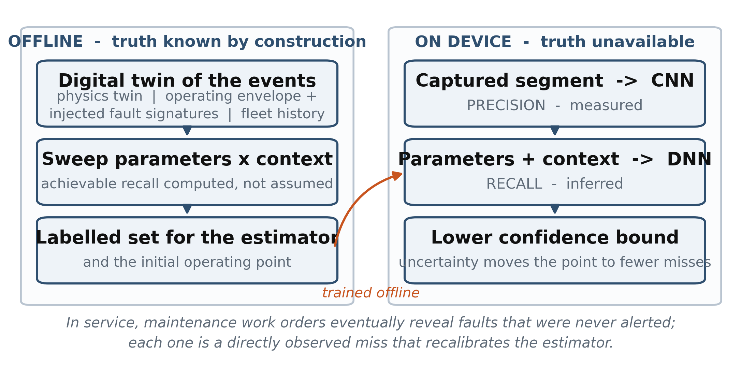
Fig. 6. How the missed-detection estimate is obtained and bounded
What bounds the inference. The estimate is conditional on the event population used to characterise it, and the project states that conditioning rather than hiding it. Three controls keep it defensible. Background and context models are calibrated against measured site data. The estimator is validated on controlled sequences where the truth is known - shake-table, impact and injected-fault tests, and replayed recordings - and its error is reported alongside the detection results rather than absorbed into them. And the optimisation acts on a lower confidence bound, so uncertainty moves the operating point towards fewer missed events. In service the conditioning weakens: work orders eventually reveal faults that were never alerted, and each is a directly observed miss that recalibrates the estimator.
Moving the operating point. The combined estimate is treated as a black-box function of the decision parameters, and a sample-efficient search - a surrogate model fitted to the evaluations completed so far, with an acquisition rule selecting the next parameter set worth trying - replaces exhaustive tuning. Sample efficiency is usually assumed to matter only where computing power is scarce; that is not why it matters here. Abundant computing power does not produce abundant ground truth: a setting can be re-evaluated at will on a mains-powered controller, but confirmation of what actually happened stays sparse and delayed. The customer's ceiling enters as a constraint on the search rather than one term among several, and the weighting of misses against false alerts is a configurable parameter. A configuration tool run once per product line sets the initial operating point, and online adaptation is confined to a validated range.
What transfers, and what is re-instantiated. The four roles are common to both profiles; what differs is how each is filled and what a false alert costs. Table 9 states that mapping, and it is the basis on which one engine and one commercial specification cover both.
Table 9. Mapping of the four loop roles to the two deployment profiles
Loop component | Role that does not change | Constrained instantiation | Resource-rich instantiation
Environment | Supplies the signal and the context that makes detection easier or harder | Excitation, structure and response, with ambient noise level as the context | Equipment operating regime: load, duty state, speed, occupancy, season and ambient conditions
System | The decision rule and its parameters | Amplitude threshold and required persistence | Threshold and confirmation policy applied to features, anomaly scores or classified events, with settings that may differ by operating regime
Estimator | Labels what was captured; infers what was missed | Onboard classification of the captured segment; achievable performance regressed from parameters and noise level | The same two functions over richer inputs, supplemented by work-order confirmation and fleet evidence
Controller | Sample-efficient search under the customer's missed-detection requirement | A few hundred evaluations within the node's time and energy budget | The same search over higher-dimensional parameter sets, limited by available confirmations rather than by computation
Cost weighed against detection | The price of a false alert, in the customer's own units | Energy per activation, storage and transmission | Operator attention, alert volume per shift and unnecessary dispatches
Cold start | Reach a good operating point before service begins | Digital twin of excitation, structure and response | Digital twin of the equipment's operating envelope, or a prior from identical fleet machines
3.2.5 Two perception modes, one common interface
Mode A: lightweight detect-wake-capture. A low-power sentinel observes one or two selected indicators continuously; CatchWise maintains the decision parameters and, after confirmation, activates the high-fidelity channel, storage or radio. Sentinel selection sets the physical detection floor; pre-trigger buffering preserves the onset; wake-up delay and standby current define the resource cost. Validated on the infrastructure event and the reference module.
Mode B: continuous multivariable/AI detect-notify-prioritise. A controller, gateway or edge computer continuously evaluates richer inputs - vibration features, temperature, current, pressure, operating state, an anomaly score or a classified event. CatchWise applies the adaptive decision policy and confirmation logic, emits the event status, marks the data window and initiates notification or maintenance-workflow integration. Validated on building mechanical equipment; industrial rotating equipment follows the same pattern.
Common interface and deployment packages. Both modes expose the same event class, sensitivity target, decision-quality indicators, event status and associated-data reference. Compact firmware and the reference module serve constrained devices; a software adapter serves gateways, controllers and existing analysis pipelines. Manufacturers keep their sensors, processors, radios, models and dashboards. Table 10 states what already exists and what this project builds.
Table 10. Platform elements: current status and work carried out in this project
Platform element | Current status | Work to be carried out in this project
Common adaptive decision engine | Adaptive estimation and search validated on the team's embedded middleware and published structural testbed. | Package a shared decision API, configuration tool, performance reporting and bounded adaptation for both runtime profiles.
Constrained detect-wake-capture profile | Dual-channel wireless sensing prototype has completed circuit design, fabrication and production-level testing. | Complete compact firmware, reference module, pre-trigger alignment and wake/resource characterisation.
Continuous multivariable/AI profile | Embedded inference and signal-processing foundations are available; the target building-equipment integration is new Gap Fund work. | Implement a controller/gateway adapter for engineered features or AI scores; validate continuous analysis and adaptive event decisions.
Common event and data interface | Research-node status output is available; BMS and industrial product boundary remains to be defined. | Define event-status, sensitivity, quality and associated-data interfaces; complete BMS/equipment integration and design review.

3.2.6 Proof-of-concept methodology
Stage 1: constrained-mode laboratory benchmarking (months 6 to 9). The published method is transferred to the reference module and tested on the selected infrastructure event, against periodic or duty-cycled sampling and conservatively tuned fixed-threshold triggering. Identical event sequences and noise conditions quantify missed detections, false alerts, detection floor, wake-up timing, pre-trigger completeness, power, storage and communications.
Stage 2: resource-rich building-equipment benchmark (months 6 to 9). A controller or gateway continuously analyses multiple signals, engineered features or an agreed anomaly output for a lift drive, chiller, pump or fan, using equipment data supplied or agreed with the partner rather than a purpose-built rig - which keeps the result representative and removes capital cost from the budget. The comparison covers commissioned fixed rules and the selected continuous-analysis baseline, measuring event coverage, false-alert volume, latency, stability across regimes and usefulness of the prioritised data.
Stage 3: pilot and integration validation (months 9 to 12). The constrained infrastructure class establishes module-level event-capture evidence; the resource-rich building class is delivered through a BMS-compatible event interface with an automation, systems-integration or equipment partner. Both stages are scored on the same five common quantities of Section 3.2.2, plus resource metrics on constrained nodes and alert-triage and integration metrics on resource-rich platforms, giving one commercial specification framework across two operating environments.

3.2.7 Comparison with the current state of the art
Basis of comparison. The constrained proof compares CatchWise with periodic or duty-cycled sampling and fixed-threshold triggering; the resource-rich proof compares it with commissioned fixed rules and a continuous AI detector using a static threshold. All alternatives receive the same event sequence and operating-state variations, isolating adaptive decision control from the choice of hardware or perception model. Table 11 tabulates the comparison parameter by parameter.
You should also state succinctly how your technology is better than the current state of the art (i.e. your secret sauce). For clear and easy comparison of your technology with commercial/state of the art, please tabulate in the format below:

Table 11. Comparison with the current state of the art
Parameters / characteristics | CatchWise proposed technology | Existing technology 1: fixed / periodic event sensing | Existing technology 2: continuous AI / anomaly monitoring
Perception input | One or two lightweight indicators, engineered features or AI anomaly scores | Scheduled samples or manually selected signal thresholds | Multiple signals, temporal features and learned anomaly models
Decision policy | Customer-defined missed-detection ceiling followed by adaptive false-alert reduction | Sampling schedule or threshold fixed at commissioning | Model score converted to alerts through application-specific thresholds and persistence rules
Response to changing conditions | Operating point adapts within a validated range using local evidence | Manual retuning as noise or operating state changes | Model retraining or rule adjustment according to the platform workflow
Action after detection | Wake/capture on constrained nodes; notify/prioritise/segment on resource-rich platforms | Record, alarm or wake according to fixed device logic | Dashboard alert, analytic insight or maintenance workflow
Performance visibility | Reports missed-detection estimate, false alerts, latency and event status | Requires scheduled testing or external ground truth | Reports anomaly/model outputs; application acceptance depends on alert configuration
Resource profile | Compact microcontroller firmware and richer controller/gateway software | Common in simple embedded devices | Controller, gateway, industrial edge or cloud-edge platform
Integration interface | Detector input, sensitivity target, event status and associated-data reference | Usually embedded in the device design | Platform APIs, dashboards and equipment connectors
Commercial route | Software/firmware licence, algorithm-enabled module, paid integration or pilot node. | Component or complete-device purchase | Platform software, subscription, analytics or services
Route to adoption | Software/firmware licence, algorithm-enabled module, technology licence or pilot node | Fixed in the node design | Fixed at design time inside closed complete products

Evidence to date. On a laboratory multi-storey test structure instrumented with the team's LiftNode sensor node, three approaches were compared on identical data (Cui et al., Mechanical Systems and Signal Processing 241 (2025) 113537). A conservatively tuned manual threshold reached 100% recall at 50.0% precision - it missed nothing, but half of what it recorded was not of interest. An off-node exhaustive search reached F-beta 0.9350 at 90.56% precision and 93.84% recall, using 15,354 times the relative computation and 15 MB of communication. The adaptive mechanism reached F-beta 0.9396 at 90.84% precision and 94.36% recall - marginally better than exhaustive search - using 1.3% of its computation and no communication, because the loop closed on the device. Irrelevant records fell from 50% to 9.2% of what was captured, while event capture stayed above 94%.
3.2.8 Deliverables, readiness and defensibility
Expected outcomes and deliverables. Six connected deliverables: (1) a productised adaptive decision engine and configuration tool; (2) compact firmware for detect-wake-capture; (3) a controller/gateway adapter for engineered features, anomaly scores or classified outputs; (4) a common event-status and associated-data interface; (5) an algorithm-enabled reference module with bill of materials and design-for-manufacture review; and (6) benchmark, pilot and integration reports for both classes, including estimator-error characterisation.
Technology readiness. The two profiles are stated separately, because the published evidence is entirely from the constrained one. That profile enters at approximately TRL 4 - laboratory-validated mechanism, fabricated node platform - and exits at TRL 5-6 after module benchmarking and a field pilot. The resource-rich profile enters at TRL 2-3, since the adapter and building-equipment integration are new work, and exits at TRL 4-5. Certification and volume manufacturing remain with equipment manufacturers or a follow-on entity. TRL wording to be confirmed with NTUitive.
Defensibility. The defensible package is not a generic thresholding idea. It is the performance estimators, sensitivity-first control, sample-efficient adaptation, dual-runtime implementation, configuration workflow, event interface and integration know-how - and above all the labelled event libraries and estimator characterisations built for each productised class, which cannot be assembled by waiting for rare failures and which strengthen with every class added.
3.2.9 Technical risks and mitigation
Perception validity and event detectability. The constrained mode needs a sentinel whose bandwidth, noise and sensitivity represent the event; the resource-rich mode needs features or scores that retain event information across operating regimes. The first three months screen both pairings, establish detection floors or separability, and fix measurable acceptance criteria before integration is committed.
Convergence under drifting conditions. Pre-deployment optimisation starts the node close to a validated operating point, and bounded online step sizes keep each update inside the validated region, stabilising the response to transient disturbances.
Estimation error. Controlled sequences with known reference labels measure the missed-detection estimator. The benchmark reports estimation error alongside detection results, which lets the project calibrate the model, define confidence bounds and document the operating range supplied to customers.
Integration uncertainty. Providers use different interfaces, drivers and validation processes. The project defines the event-status and data interface with a partner that controls the relevant gateway, controller or device, and records integration effort as an acceptance indicator; the reference module provides a parallel path and a stable integration baseline.

4. Project Milestones

Describe specific project timeline in terms of “project months or weeks” for meeting of quantifiable milestones such as attaining certain technical specifications, fabrication, testing, refinement, field tests, etc.
Milestone structure. The 18-month project retains 15 months for execution and three months for contingency. Each phase includes quantifiable gates so progress reports show commercialisation evidence rather than only development activity. The Month 7 and Month 13 NTUitive progress reports align with the benchmark and pilot/integration checkpoints. Table 12 gives the phase-by-phase plan.

Table 12. Project milestones, deliverables and phase gates
Start | End | Description
Month 0 | Month 3 | Use-case, perception-mode and acceptance definition. Activities: select one constrained infrastructure event and one resource-rich building mechanical anomaly; define detection ceiling, false-alert baseline, latency target, event-data completeness, integration KPI and partner data requirements. Deliverables: requirements note, labelled-data protocol, baseline test plan and partner-confirmed acceptance metrics. Gate: both event-perception pairings must pass detectability screening before implementation commitment.
Month 3 | Month 6 | Dual-mode engine, interfaces and reference module. Activities: package adaptive estimation/search; implement compact firmware, continuous multivariable/AI adapter, event-status output, event-driven switching and data-window assembly. Deliverables: testable software release, configuration tool, BMS/equipment interface, working reference modules and preliminary integration specification. Gate: both detector-input paths produce a common event status and associated-data reference.
Month 6 | Month 9 | Cross-mode detection and notification benchmarking. Activities: compare constrained mode with periodic/fixed thresholds and resource-rich mode with static-rule or static-AI-score decisions. Deliverables: benchmark datasets and interim report. Quantifiable gates: missed-detection ceiling met for the selected event class; false-alert reduction measured against baseline; latency, estimator error, power/storage/communication load and alert-prioritisation metrics reported.
Month 9 | Month 12 | Partner validation: infrastructure field pilot and gateway-level integration. Activities: run infrastructure pilot to module level; integrate the building-equipment class through partner gateway/controller or agreed laboratory gateway; re-measure the false-alert cost parameters in operation against the Month 0-3 baseline. Deliverables: pilot/integration report covering notification, alert usefulness, integration hours, incremental cost and user acceptance. Contingency: if partner scheduling slips, use University-accessible site and partner-supplied/replayed data.
Month 12 | Month 15 | Commercial package and scale-up preparation. Activities: finalise engine, firmware, adapter, event interface, reference module, pricing hypotheses and licensing/module offers. Deliverables: final benchmark package, integration guide, bill of materials/design-for-manufacture review, value-based pricing evidence and preliminary licensing/module terms. Gate: select preferred commercial route based on partner evidence and economics.
Month 15 | Month 18 | Contingency, consolidation and follow-on engagement. No new technical or commercial deliverable is scheduled: this phase absorbs schedule risk carried forward from earlier phases. Activities as needed: repeat inconclusive tests, incorporate partner feedback, convert late partner interest into dated support letters or LOIs, and advance the follow-on funding and licensing discussions opened in Months 12-15. Deliverables: final project report and industry-engagement record, plus any endorsements obtained. Note: supports NTUitive final reporting.

5. Budget
Budget basis. The budget allocates direct incremental costs incurred at NTU across the 18-month project, in line with the scheme guidelines. Figures are indicative, inclusive of prevailing Goods and Services Tax and stated net of overheads. Manpower is charged fractionally according to project commitment and accounts for 72% of the request, reflecting a software-led project with limited prototype fabrication. Lead PI and existing contributor time is treated as in-kind support. Patent filing, patent maintenance, overheads and general administrative costs are excluded from the Gap Fund request. Table 13 gives the breakdown by cost category.

Table 13. Budget by cost category
Manpower (EOM)  1 x Research Fellow (adaptive detection algorithms and embedded productisation), 100% FTE for 18 months, at an indicative loaded cost of S$7,500 per month. Scope: algorithm package, onboard implementation, configuration and alert interfaces, reference-module integration, benchmarking and pilot support. Subtotal S$135,000.  1 x Research Assistant / Project Officer (test engineering, ground-truth labelling and data analysis), 100% FTE for 10 months, at an indicative loaded cost of S$4,300 per month. Scope: benchmark set-up and execution, labelled reference sequences, estimator-error measurement and documentation. Subtotal S$43,000.  [appointment titles and effort allocation] Lead PI and existing contributor time is in-kind. | S$178,000
Equipment  Precision power and energy measurement instrument for microampere-level standby and event-cycle characterisation: S$9,000.  Reference accelerometer, multichannel data acquisition and edge-computing gateway for ground truth and resource-rich adapter runtime: S$8,000.  Commercial baseline devices for like-for-like benchmarking, covering fixed-threshold/duty-cycled monitoring nodes and impact or shock recorder, three to four units: S$12,000.  [equipment models, vendor quotations and procurement classification] | S$29,000
Other Operating Expenditure (OOE)  PCB fabrication and assembly across two iterations, including prototype and pilot units: S$12,000.  Electronic components, sentinel/high-fidelity sensors, multivariable interfaces, batteries, enclosures and cabling: S$8,000.  Third-party characterisation and design-for-manufacture review services, including environmental and pre-compliance testing: S$6,000.  Pilot and integration costs for gateway/software interfaces, mounting hardware, installation consumables, equipment transport and site logistics: S$6,000.  Local travel for partner engagement and pilot supervision: S$4,000.  Laboratory consumables: S$2,000.  [vendor quotes and partner-site logistics] | S$38,000
Total | S$245,000
*Please leave out overheads when planning for budget at this stage
Alignment with milestones. Expenditure follows the phases in Section 4. Measurement instrumentation, edge gateway and commercial baseline devices are procured in Months 0-3 so benchmarks can begin on schedule. PCB fabrication spans Months 3-12 across two module iterations. Pilot and integration costs fall mainly in Months 9-15. The resource-rich benchmark avoids dedicated capital equipment by using [partner data and gateway access].

6. Funding Sources

Please provide details of all sources of funding related to the technology proposed, previously and currently held or being applied for by any of the team members.
Scope of this section. Table 14 presents the funding sources related to the underlying technology that are currently or previously held by team members. [funding period] [funding amount] [funding status]

Table 14. Related funding sources currently or previously held by team members
Funding Source  (include industry funding/investment) | Funding Period | Deliverables | Funding Amount
MOE AcRF Tier 1, RG146/23 (currently held) | [funding period] | Fundamental research on wireless IoT sensing and edge intelligence for structural health monitoring; deliverables are methods, publications and laboratory demonstrations. Provides part of the scientific basis for the triggering mechanism. | [funding amount]
NTU CoE Dean's Interdisciplinary Grant 2024, 03INS002320C120 (currently held) | [funding period] | Interdisciplinary research on edge intelligence and sensing system architecture; deliverables are research outcomes and platform capability. Supports the embedded computing middleware on which the adaptive layer runs. | [funding amount]
Coastal Protection and Flood Management Research Programme, CFRP-AR01-V4-P1 (awarded): Smart continuous monitoring system for coastal infrastructure based on distributed fibre-optic sensing and wireless IoT technologies | [funding period] | Applied research on continuous monitoring of coastal infrastructure; deliverables relate to a monitoring system for that context. Provides an application setting and industry contacts in coastal monitoring. | [funding amount]
Cities of Tomorrow (CoT) programme: Novel wireless multi-metric IoT sensing system for real-time structural health monitoring [funding status] | [funding period] | Development of a multi-metric wireless IoT sensing platform for structural health monitoring; deliverables relate to that platform. Provides a complementary application and sensing platform. | [funding amount]
MOE AcRF Tier 1, RG121/21 (previously held) | [funding period] | Earlier fundamental research on demand-based, energy-efficient wireless smart sensing. Completed work contributing to the background technology. | [funding amount]
NTU Start-up Grant, 03INS001210C120 (previously held) | [funding period] | Start-up support for the Principal Investigator's research programme in smart sensing and structural health monitoring. Contributed to the background technology. | [funding amount]
AI Singapore translational project, AISG2-TC-2021-001 (previously held) | [funding period] | AI-enabled smart sensing for underground transport infrastructure, conducted with the Land Transport Authority. Completed translational work providing prior application experience and industry engagement. | [funding amount]

Demarcation from the proposed work. The projects above support underlying sensing science, wireless node platforms, embedded middleware and application demonstrations. This Gap Fund application funds incremental commercialisation work: a productised decision engine, defined interface, reference module, benchmarking against customer alternatives, partner validation and commercial package. Section 5 allocates costs only to these incremental activities.
- Past Application Submission(s)

Why was your previous application unsuccessful?

Please provide details on the improvements and upgrades made in comparison.
This is the team's first application under the NTUitive Gap Fund scheme. [Gap Fund application history]

- Declaration by Principal Investigator

I declare that all the above information provided is true and complete to the best of my knowledge.

Name and Signature of Principal Investigator |  | Date

☐ Please tick if you are a research staff. Your supervisor’s endorsement of your application as Principal Investigator is required below.

☐ Please tick if you are a PhD student. I confirm that my scholarship allows me to participate in this POC project, and I will remain in NTU until its completion. Your supervisor’s endorsement of your application as Principal Investigator is required below.

Name and Signature of Supervisor (Faculty) |  | Date

ANNEX A

It is compulsory to fill in the Business Model Canvas for your project. You may submit in a separate sheet due to space constraint.

Designed for: CatchWise: Edge-AI Event & Anomaly Capture for Monitoring Systems

Key Partners  BMS/Smart FM providers and system integrators; infrastructure monitoring and sensing manufacturers; industrial equipment/sensing partners; field users including facilities teams, infrastructure owners, plants and logistics operators; NTUitive and electronics manufacturers. [specific partner names and disclosure permission] | Key Activities  Productise one adaptive decision engine for compact and richer runtimes.  Build the continuous multivariable/AI adapter and BMS event interface.  Benchmark constrained infrastructure and resource-rich building modes.  Run partner integration, field validation and customer discovery.  Prepare parallel software/firmware-licence, module and support packages. | Value Propositions  Detect the user's defined event or anomaly and notify the responsible person or platform.  Keep missed events at or below an agreed ceiling, then reduce false alerts.  Support lightweight detect-wake-capture and continuous multivariable/AI monitoring through one decision layer.  Focus power and data on constrained nodes; focus alerts, review and response on resource-rich systems.  Deploy through software/firmware licence or algorithm-enabled module, with integration packages and pilot nodes where required. |  | Customer Relationships  Joint definition of event and notification KPIs; paid integration and device-level validation; portfolio or per-endpoint licensing; module supply; continuing connector/configuration support. [LOI/support-letter status] | Customer Segments  Primary scale market: BMS and Smart FM providers/integrators.  First validation market: infrastructure-monitoring providers and users.  Next replication: industrial condition-monitoring suppliers and plants.  Later: transport/logistics recorders.  Future adjacency: home and assisted-living safety.
 | Key Resources  Adaptive detection algorithm, onboard estimators and search method.  Implementation and event-class configuration know-how.  Reference sensing module and embedded middleware.  BMS-compatible event interface.  Benchmark datasets, test rigs and integration documentation. |  |  | Channels  NTUitive technology licensing; direct software/firmware licensing; module sales to equipment manufacturers and integrators; infrastructure pilot nodes for first proof; BMS/Smart FM integration partners; regional partners in Southeast Asia and China. [specific channel partners]
Cost Structure  Algorithm and firmware productisation; labelled data and validation.  Reference-module fabrication and testing.  BMS and equipment interfaces, connectors and support.  Infrastructure and building-equipment pilots.  IP/commercial work and partner engagement. |  |  | Revenue Streams  Software/firmware licensing to BMS, Smart FM, industrial and equipment providers.  Algorithm-enabled module sales to manufacturers, integrators and projects.  Technology and implementation-know-how licensing.  Paid interface adaptation and joint development.  Recurring connector, update or configuration support.  Complete pilot-node sales.

Suggested reading references:
- Business Model Generation by Alexander Osterwalder and Yves Pigneur
- Value Proposition Design by Alexander Osterwalder, Yves Pigneur, Greg Bernarda, Alan Smith

This is essentially a process or cycle of introducing a new product into the market. This includes the need to consider how the prototype or device can successfully enter the market in a sustained and long-term manner. It should also consider the likely customers or users of this new technology.

